Airlines Management System

## Team Details

**Team ID :** LTVIP2025TMID31350

**Team Size :** 4

**Team Leader :** Sree Satya Kammula

**Team member :** Rajulapati Satyasree

**Team member :** Renuka Maddi

**Team member :** Polukonda Renuka Devi

# INTRODUCTION

Project Overview

This project aims to enhance the efficiency and effectiveness of managing flights, reservations, and passenger information. The system enables airlines to manage their fleet, schedule flights, allocate seats, and handle bookings seamlessly. It provides functionalities for ticket reservations, seat availability checks, passenger check-ins, and baggage handling. Additionally, the system facilitates communication between airlines, airports, and passengers through automated notifications and alerts. With itsuser-friendly interface and robust database management, the Airlines Management System optimizes workflow, improves customer satisfaction, and ensures smooth operations for the entire airline industry.

Purpose

The purpose of the Airline Management System is to automate and streamline the core operations of airline companies, including flight scheduling, ticket reservations, passenger management, and communication processes. By digitizing these functions, the system aims to:

1. Improve the efficiency of airline operations
2. Reduce manual errors and administrative workload
3. Enhance the passenger experience through faster and more reliable services
4. Enable real-time communication and updates for both staff and passengers
5. Ensure secure and organized data management for all airline-related activities

# IDEATION PHASE

### Problem Statement

Airlines today manage a vast range of operations including flight scheduling, ticket reservations, seat assignments, passenger check-ins, and real-time communication. Many existing systems are either manual, fragmented, or outdated, leading to common issues such as:

1. Overbookings and mismanaged seat allocations
2. Delayed or missed passenger notifications

### Empathy Map Canvas

* + **Who?** Passengers and airline staff
  + **Think/Feel?** Passengers feel uncertain about bookings; staff feel overloaded
  + **See?** Delays, manual work, lack of real-time updates
  + **Say/Do?** Frequent inquiries, manual check-ins
  + **Hear?** Complaints about poor communication and delays
  + **Pain?** Disconnected systems, booking confusion, inefficient operations
  + **Gain?** Streamlined processes, automated updates, improved experience

### Brainstorming

Considered:

* + Manual flight and ticket booking using paper-based records
  + Excel sheets for tracking flights, seat availability, and passenger details
  + Web-based Airline Management System – chosen for its scalability, automation, real-time data handling,and integration with notification and check-in modules

# REQUIREMENT ANALYSIS

### Customer Journey Map

The customer journey begins when a passenger logs into the airline portal. They search for available flights based on their preferred route and date, view seat availability, and proceed to book a ticket. Upon confirming the booking, the system triggers automated workflows for seat allocation, check-in eligibility, and payment confirmation. Notifications are sent at each step, and the passenger receives updates regarding boarding time, gate number, and baggage status.

### Flow:

Passenger logs in → Searches for flights → Selects flight and seat → Books ticket → Workflow triggered → Seat allocated and payment processed → Notification sent → Check-in completed → Boarding and travel

### Solution Requirements

To meet the needs of a streamlined and automated airline operation process, the following components are required:

* A centralized system for flight listings and reservations
* Categories: Domestic, International, Connecting Flights
* Flight listings with details: flight number, departure/arrival time, seat availability, and fare
* Real-time seat allocation and booking interface
* Check-in and boarding pass generation
* Automated workflow for booking confirmation and check-in
* Notifications for booking status, gate updates, and flight delays

### Data Flow Diagram

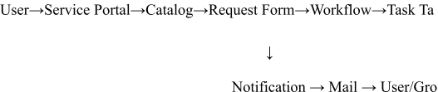

**Technology Stack**

* **Platform**: Salesforce Lightning Platform
* **Languages/Scripting**: Apex (for backend business logic using Salesforce's proprietary lan

Lightning Web Components and Aura Components (for frontend U SOQL/SOSL (for querying Salesforce data)

* **Modules Used**: HTML/CSS/JavaScript (for custom UI and

email templates)

* + Service Cloud
  + Service Cloud
  + Flow Builder
  + Reports & Dashboards
  + Role-Based Access & Profiles

#### Testing Method:

1. Manual Testing via Salesforce Lightning Experience and Experience C
2. Apex Test Classes for validating logic and workflows (with 75%+ cod coverage required for deployment)

# PROJECT DESIGN

### Problem-Solution Fit

The traditional approach to managing airline operations—such as flight scheduling, seat allocation, and passenger check-ins—is often fragmented and manual, leading to delays, booking errors, and poor passenger communication. These inefficiencies result in reduced customer satisfaction and increased workload for airline staff.

The Airline Management System addresses these challenges by introducing a central ized, automated platform that integrates flight booking, real-time seat tracking,

check-in management, and notification systems. This ensures smooth operations, accurate reservations, timely updates, and a better overall experience for both passengers and airline personnel. It enhances operational transparency, minimizes errors, and streamlines the

end-to-end airline workflow.

### Proposed Solution

To address the problem effectively, the following components were implemented:

* Flight Catalog Setup: A centralized flight catalog was created to manage all scheduled flights with key information like origin, destination, fare, and timing.
* Categories: Flights were organized into categories such as Domestic, International, and Connecting Flights for easier search and filtering.
* Flight Listings: Each listing included rich details like airline name, flight number, departure/arrival time, duration, available seats, and pricing.
* **Roles:** Custom roles (e.g., Passenger, Check-in Staff, Operations Manager) were defined to ensure controlled access and feature visibility based on user responsibility.
* **Groups:** Operational groups (e.g., Check-In Team, Flight Operations, Customer

Service) were created for workflow handling and task assignment.

* **Custom Object:**Dedicated Salesforce objects such as Flights, Bookings, Passengers, and Check-In Logs were designed to store and manage airline data.
* **Workflows:** Automated multi-step workflows were implemented for:
  1. Ticket Booking & Confirmation
  2. Seat Allocation
  3. Check-In Processing
  4. Notifications for Booking, Delays, and Gate Changes

**Solution Architecture**

## Frontend:

The Airline Portal (built with Salesforce Experience Cloud or a custom web interface) serves as the user interface. Passengers can search for flights, view schedules, book tickets, and check in seamlessly.

## Logic Layer:

This layer includes Flows, Apex Triggers, and Lightning Components to handle: Automated ticket booking and seat assignment

Dynamic form behaviors (e.g., date/time validations)

Workflow-based actions (e.g., check-in or cancellation approvals) Conditional UI rendering based on user role

## Backend (Data Layer):

Custom Salesforce Objects store and manage flight data, passenger records, seat allocation, booking status, and check-in logs.

Statuses such as “Checked-In”, “Boarded”, or “Cancelled” are tracked in real time.

## Notifications Layer:

Configured Email Alerts and SMS integrations provide real-time updates to passengers and airline staff regarding booking confirmations, gate changes, flight delays, or cancellations.

## Access Control:

Role-based access is enforced using Profiles, Permission Sets, and User Groups.

For example, only airline operations staff can manage flight records, while passengers can only view and modify their bookings.

# PROJECT PLANNING & SCHEDULING

The project followed a structured and iterative development process to ensure effective implementation, testing, and deployment of all key features. The development was divided into the following major phases:

* + **Catalog Structure Setup** : Developed the primary catalog containing categorized flight

options, such as Domestic, International, and Connecting Flight for better organization and usability.

* + **Catalog Item Configuration** : Added detailed flight listings including airline name,

flight number, departure/arrival times, duration, fare, and real-time seat availability.

* + **User and Role Management** : Created user profiles for Passengers, Check-in Staff, and

Operations Managers. Assigned roles and permissions to ensure proper access control across modules.

#### Database and Workflow Design: Designed custom Salesforce objects to manage Flights, Bookings, Seats, and Check-ins. Configured automated workflows for ticket booking, seat allocation, and check-in confirmation.

* + **Portal Configuration** : Set up a user-facing Airline Portal using Salesforce Experience Cloud (or a custom web interface) to

allow easy flight search, booking, and check-in processes.

* + **Notification Integration:** Implemented email and SMS notifications to alert

users of booking status, gate changes, delays, and

check-in confirmation Used dynamic templates for personalized messaging.



# IMPLEMENTATION WORKFLOW

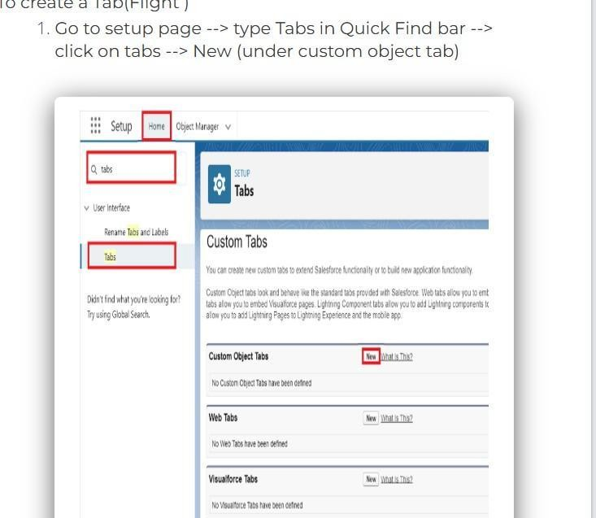This section outlines the step-by-step process followed to implement the Airline Management System on the Salesforce platform:

1. Create Custom Objects for Airline Data
2. Go to Setup in Salesforce.
3. Under Object Manager, click Create → Custom Object.
4. Create objects such as:.

a. Flight c – to store flight details .

b. Booking c – to manage ticket reservations .

c. Passenger c – to store passenger information

d. CheckIn c – to manage check-in and boarding statuses

1. Add relevant fields like Flight Number, Departure Time, Arrival Time, Seat Availability, etc.

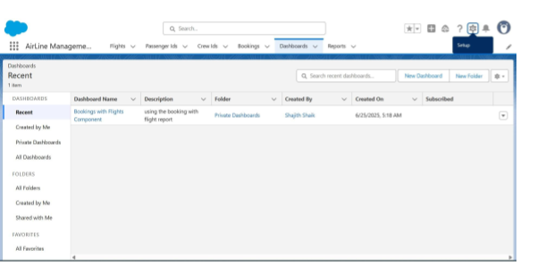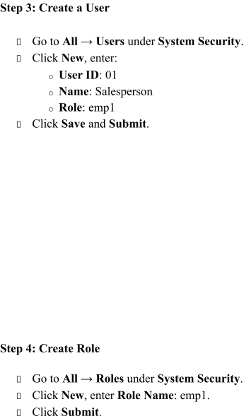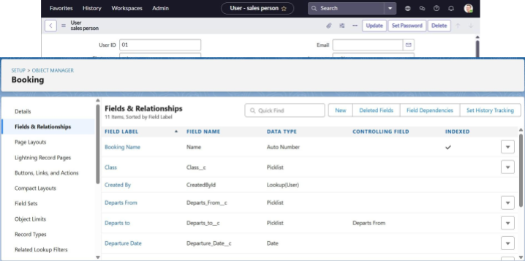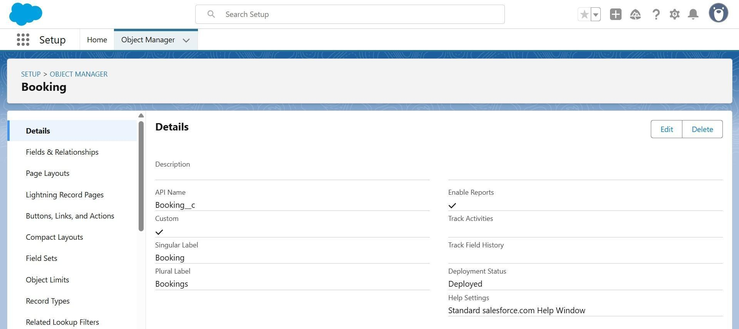

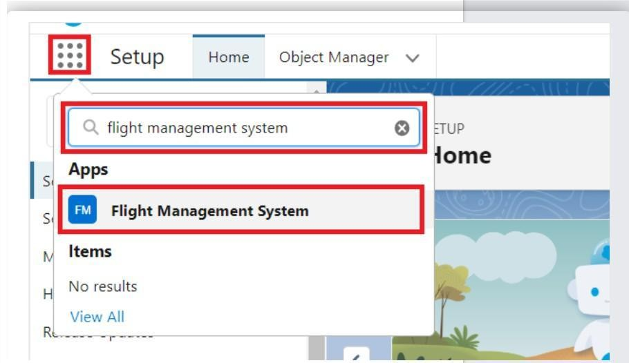

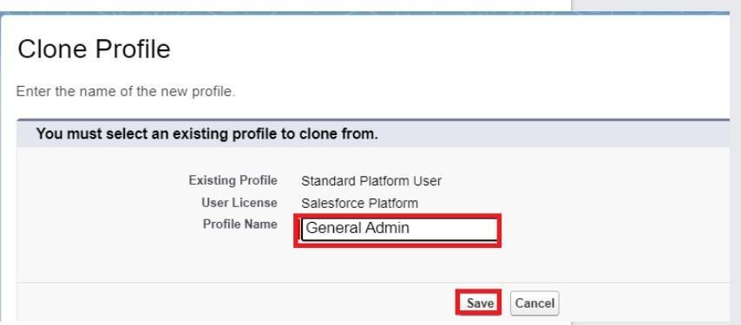

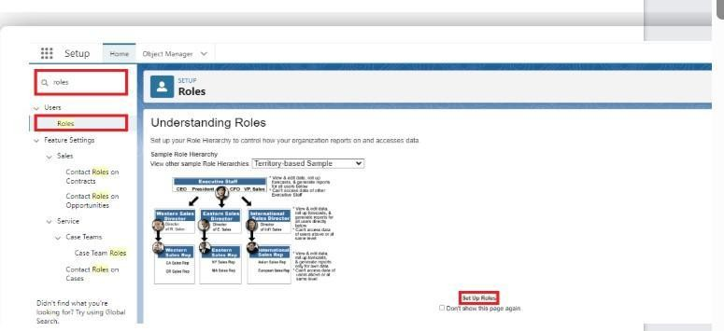

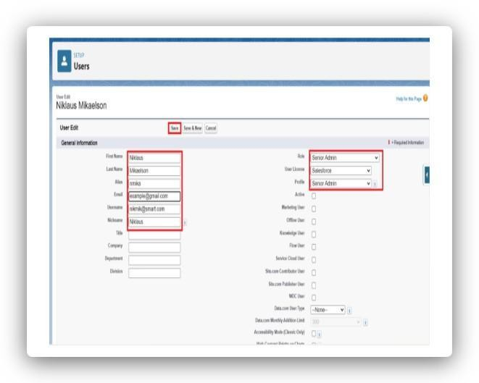

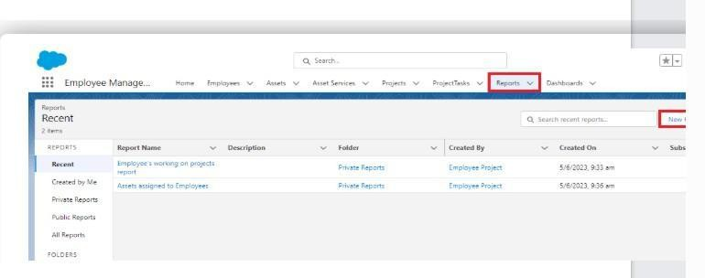

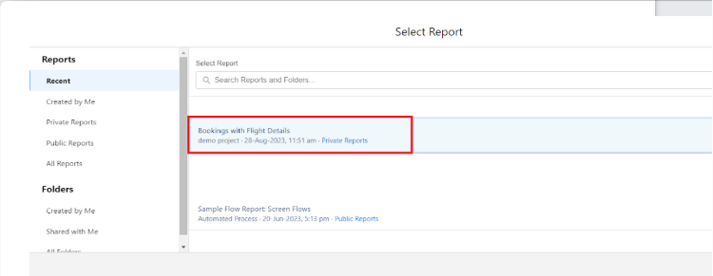

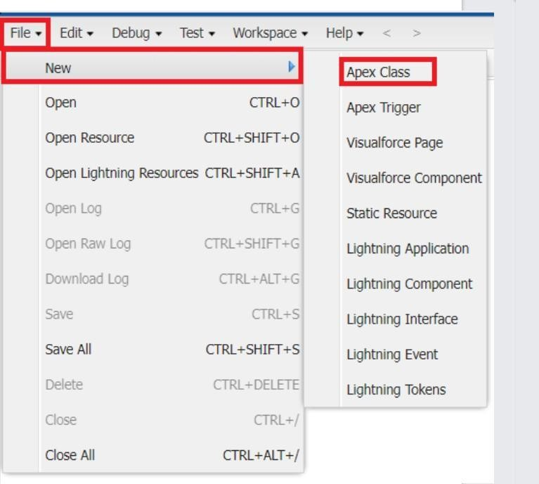

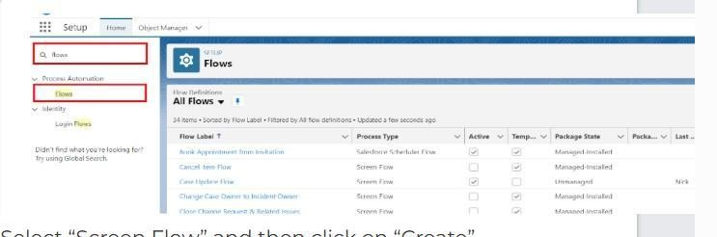

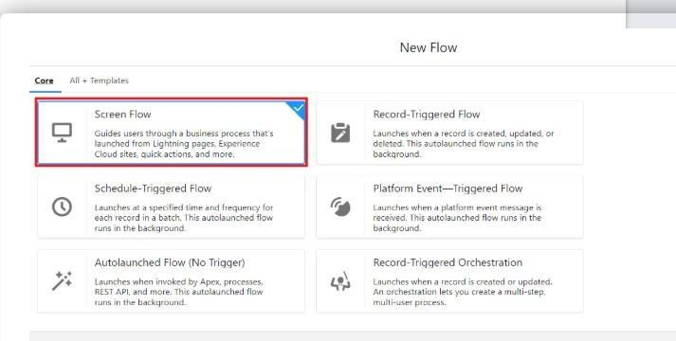

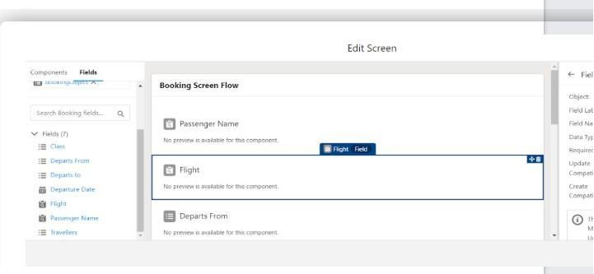

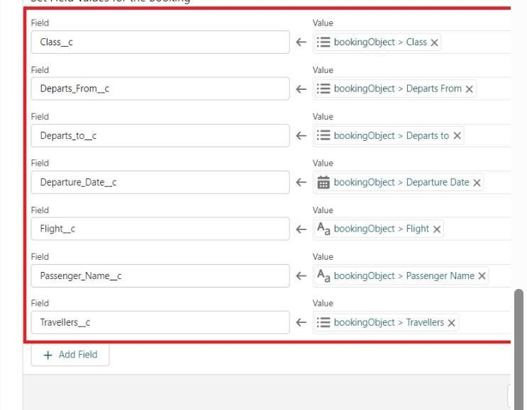

### Performance Testing

Flight search and booking forms load correctly with appropriate flight data Fare, timing, and seat availability are displayed accurately for each flight Seat allocation and booking workflows are triggered and processed as expected Email/SMS notifications are sent correctly based on booking status and flight updates Bookings and check-in records appear in the corresponding custom objects and related lists All input fields and relationships (Flight → Booking → Passenger) are validated for correctness User roles and



permissions were tested to ensure secure access to data and features

# ADVANTAGEDISADVANTAGES

### Advantages

* 1. Fully automated booking, seat allocation, and check-in system
  2. User-friendly interface for both passengers and airline staff
  3. Real-time notifications enhance communication and reduce confusion
  4. Centralized data system ensures better tracking and coordination
  5. Scalable architecture allows for easy integration of new features (e.g., payment gateway, loyalty program)

### Disadvantages

1. Requires Salesforce admin-level knowledge to configure objects, roles, and flows
2. Initial setup of workflows and relationships can be time-consuming
3. May incur higher licensing costs if using advanced Salesforce modules
4. Dependency on internet connectivity for real-time operations

# CONCLUSION

The Airline Management System offers a comprehensive and efficient digital solution

for handling airline operations. By integrating flight scheduling, ticket booking, seat allocation, passenger check-in, and automated notifications, the system ensures smooth and transparent

processes across all stages of the travel journey.

The structured architecture allows passengers to easily search for flights, book tickets, and receive timely updates, while airline staff benefit from reduced manual effort and better

workflow management. Automated approvals and centralized data tracking enhance operational efficiency and improve overall passenger satisfaction.

# FUTURE SCOPE

* 1. Passenger Feedback & Ratings:

Enable passengers to leave feedback or ratings for flights, improving service quality and helping future travelers make informed choices.

* 1. Role-Based Dashboards:

Implement interactive dashboards for roles like admin, check-in staff, and flight managers to display key metrics such as booking volumes, occupancy rates, and flight punctuality.

.

* 1. Advanced Notifications Integration:

∙

In t e g rt a te W hatsApp, push notifications, or in-app alerts for real-time updates on

booking confirmations, gate changes, and delays.

* 1. Group Booking Capability:

Allow passengers to book tickets for multiple travelers in a single request—ideal for family trips, corporate travel, or group tours.

* 1. Payment Gateway Integration:

Integrate online payment options for booking tickets directly within the portal, ensuring a seamless user experience.

* 1. AI-Based Flight Recommendation Engine:

Use historical data and preferences to recommend flights, timings, and airlines tailored to each passenger.

